**TASK FOR COLOR IMAGE PROCESSING**

**Task 1: Answer WHY?**

1. What is a color space?

a) A specific organization of colors

b) A technique for image compression

c) A method for detecting edges in an image

d) A filter used in image enhancement

Answer: a) A specific organization of colors

A color space is a model describing the way colors can be represented as tuples of numbers, typically as three or four values or color components. It defines a particular way to represent colors in numerical terms, making it possible to manage and manipulate colors in various digital and physical media.

2. Which color space is commonly used in digital screens and cameras?

a) HSV

b) YUV

c) RGB

d) CMYK

Answer: c) RGB

The RGB (Red, Green, Blue) color space is used because it aligns with the way digital screens and cameras capture and display images. Each color is represented as a combination of these three primary colors.

3. Why is the HSV color space often used for color-based segmentation?

a) It is more computationally efficient than RGB.

b) It separates color information (hue) from intensity, making it easier to isolate specific colors.

c) It is the default color space for all image processing libraries.

d) It reduces the number of colors in an image.

Answer: b) It separates color information (hue) from intensity, making it easier to isolate specific colors.

HSV (Hue, Saturation, Value) separates the color information (hue) from the intensity (value), making it easier to perform tasks like color-based segmentation, where isolating specific colors regardless of lighting conditions is beneficial.

4. How do you convert an image from RGB to HSV in Python using OpenCV?

a) cv2.convertColor(image, cv2.COLOR_RGB2HSV)

b) cv2.cvtColor(image, cv2.COLOR_RGB2HSV)

c) cv2.transformColor(image, cv2.COLOR_RGB2HSV)

d) cv2.colorTransform(image, cv2.COLOR_RGB2HSV)

Answer: b) cv2.cvtColor(image, cv2.COLOR_RGB2HSV)

The cv2.cvtColor function in OpenCV is used to convert images from one color space to another. The correct syntax to convert an RGB image to HSV is cv2.cvtColor(image, cv2.COLOR_RGB2HSV).

5. What is color quantization?

a) The process of converting an image to grayscale.

b) The process of reducing the number of colors in an image.

c) The process of enhancing the colors in an image.

d) The process of adjusting the brightness of an image.

Answer: b) The process of reducing the number of colors in an image.

Color quantization reduces the number of distinct colors in an image, making it simpler and often smaller in size, while still maintaining a visual similarity to the original image.

6. What is the purpose of histogram equalization in color images?

a) To reduce the image size.

b) To enhance the contrast of the image.

c) To blur the image.

d) To convert the image to grayscale.

Answer: b) To enhance the contrast of the image.

Histogram equalization is used to improve the contrast in images by redistributing the intensity values more evenly across the histogram, making the details in the image more distinguishable.

7. In the context of color image processing, what does "white balance" refer to?

a) Adjusting the image's contrast.

b) Reducing the number of colors in an image.

c) Correcting the image colors to make white areas appear white under different lighting conditions.

d) Converting the image to the HSV color space.

Answer: c) Correcting the image colors to make white areas appear white under different lighting conditions.

White balance adjusts the colors in an image to ensure that white objects appear white, compensating for different lighting conditions that can cast color tints on the image.

8. What is a common application of color tracking in video processing?

a) Identifying text in a document.

b) Detecting edges in a video.

c) Following the movement of a specific colored object.

d) Compressing the video file size.

Answer: c) Following the movement of a specific colored object.

Color tracking is often used in video processing to follow or detect the movement of objects based on their color, which is useful in applications like surveillance, object tracking, and augmented reality.

9. Which method is used to find the dominant colors in an image?

a) Histogram equalization

b) K-means clustering

c) Gaussian blur

d) Edge detection

Answer: b) K-means clustering

K-means clustering is an algorithm that partitions the image into K clusters, identifying the dominant colors by grouping similar colors together, which is useful for tasks like color palette extraction and image segmentation.

10. What is the Gray World Assumption used for in color image processing?

a) To detect edges in an image.

b) To reduce noise in an image.

c) To achieve color constancy by assuming the average color of a scene is gray.

d) To enhance the image's contrast.

Answer: c) To achieve color constancy by assuming the average color of a scene is gray.

The Gray World Assumption is a method for color constancy that assumes the average color in a scene is neutral gray. It adjusts the colors in the image accordingly to maintain consistent colors under varying lighting conditions.

11. Which library in Python is commonly used for color image processing?

a) NumPy

b) SciPy

c) OpenCV

d) Pandas

Answer: c) OpenCV

OpenCV (Open Source Computer Vision Library) is widely used for computer vision and image processing tasks, including color image processing, due to its extensive functionality and ease of use.

12. What does the Y channel represent in the YUV color space?

a) Hue

b) Saturation

c) Luminance (brightness)

d) Chroma (color)

Answer: c) Luminance (brightness)

In the YUV color space, the Y channel represents the luminance or brightness information of the image, while the U and V channels represent the chrominance (color) information.

13. Why is the YUV color space commonly used in video compression?

a) It is computationally simpler than RGB.

b) It separates luminance from chrominance, which allows more efficient compression.

c) It uses fewer bits than RGB.

d) It enhances the video quality.

Answer: b) It separates luminance from chrominance, which allows more efficient compression.

The YUV color space separates luminance (Y) from chrominance (U and V), allowing more efficient compression by prioritizing the Y channel, which is more perceptually important to the human eye, and compressing the U and V channels more aggressively.

14. Which color space is typically used in printing and publishing?

a) RGB

b) HSV

c) YUV

d) CMYK

Answer: d) CMYK

CMYK (Cyan, Magenta, Yellow, Key/Black) is used in printing because it aligns with the color mixing process of inks and dyes used in printers, allowing for accurate color reproduction on paper.

15. What is the main challenge of processing color images compared to grayscale images?

a) Color images require more storage space.

b) Color images are less detailed.

c) Color images contain more information and complexity due to multiple channels.

d) Color images are harder to display.

Answer: c) Color images contain more information and complexity due to multiple channels.

Color images are more complex to process than grayscale images because they have multiple channels (e.g., RGB) with more information, requiring more computational resources and sophisticated algorithms.

**Task 2: Answer by key words**

• **What is a color space, and how do different color spaces represent color information?**

* **Key Words:** Color space, representation, RGB, HSV, CMYK, YUV, numerical values, components.

• **How do you convert an image from the RGB color space to the HSV color space and vice versa?**

* **Key Words:** RGB to HSV, HSV to RGB, conversion, OpenCV, cv2.cvtColor.

• **What are the advantages of using the HSV color space over the RGB color space for certain image processing tasks?**

* **Key Words:** HSV advantages, hue separation, intensity, color segmentation, lighting conditions.

• **How does the YUV color space differ from the RGB color space, and where is it commonly used?**

* **Key Words:** YUV vs RGB, luminance, chrominance, video compression, broadcasting.

• **What is color quantization, and why is it important in image processing?**

* **Key Words:** Color quantization, reducing colors, image simplification, storage efficiency.

• **How do you perform color-based segmentation in an image using OpenCV?**

* **Key Words:** Color-based segmentation, OpenCV, cv2.inRange, mask, thresholding.

• **What are color histograms, and how can they be used to analyze an image's color distribution?**

* **Key Words:** Color histograms, color distribution, analysis, frequency, channels.

• **How can histogram equalization be applied to color images?**

* **Key Words:** Histogram equalization, color images, contrast enhancement, CLAHE, channel processing.

• **What is the process of color correction, and what techniques are commonly used?**

* **Key Words:** Color correction, white balance, gamma correction, color grading, techniques.

• **How does white balance adjustment work in color image processing?**

* **Key Words:** White balance, color adjustment, lighting conditions, true white, correction.

• **What is color constancy, and why is it a challenging problem in image processing?**

* **Key Words:** Color constancy, perception, lighting variations, challenge, true colors.

• **How do algorithms like Gray World Assumption and Retinex help in achieving color constancy?**

* **Key Words:** Gray World Assumption, Retinex, color constancy, average color, scene correction.

• **What are the common methods for image enhancement in color images?**

* **Key Words:** Image enhancement, methods, contrast adjustment, sharpening, noise reduction.

• **How do you handle noise in color images, and what are the best practices for noise reduction?**

* **Key Words:** Noise handling, color images, noise reduction, filters, best practices.

• **What role do filters play in color image processing, and how are they applied?**

* **Key Words:** Filters, color image processing, application, smoothing, sharpening, edge detection.

• **How can edge detection be performed on color images, and what are the challenges compared to grayscale images?**

* **Key Words:** Edge detection, color images, challenges, channel separation, gradients.

• **What is the significance of color models like CMYK in printing and publishing industries?**

* **Key Words:** CMYK, printing, publishing, significance, color reproduction, ink mixing.

• **How do you implement color tracking in videos for object detection and tracking?**

* **Key Words:** Color tracking, videos, object detection, implementation, OpenCV, algorithms.

• **What are the challenges of processing images with varying lighting conditions, and how can they be addressed?**

* **Key Words:** Varying lighting, image processing, challenges, white balance, exposure correction.

• **How can machine learning be applied to color image processing tasks?**

* **Key Words:** Machine learning, color image processing, applications, algorithms, classification.

• **What is the role of deep learning in enhancing and understanding color images?**

* **Key Words:** Deep learning, enhancement, understanding, color images, neural networks, models.

• **How do you perform color-based object recognition and classification?**

* **Key Words:** Color-based recognition, object classification, techniques, algorithms, accuracy.

• **What are the applications of color image processing in medical imaging?**

* **Key Words:** Medical imaging, color image processing, applications, diagnostics, visualization.

• **How is color image processing used in augmented reality (AR) and virtual reality (VR)?**

* **Key Words:** AR, VR, color image processing, applications, enhancement, environment interaction.

• **How do image compression techniques handle color information, and what are some common algorithms?**

* **Key Words:** Image compression, color handling, algorithms, JPEG, PNG, efficiency.

• **What is the importance of color balance in photography and digital imaging?**

* **Key Words:** Color balance, importance, photography, digital imaging, true colors, aesthetics.

• **How do you create color palettes from an image, and what are the applications of this technique?**

* **Key Words:** Color palettes, creation, applications, design, image analysis, branding.

• **How can you use color image processing to detect and analyze patterns in remote sensing images?**

* **Key Words:** Remote sensing, pattern detection, analysis, color image processing, applications.

• **What are the ethical considerations in manipulating colors in digital images?**

* **Key Words:** Ethical considerations, color manipulation, digital images, integrity, accuracy.

• **How can you evaluate the performance of color image processing algorithms, and what metrics are commonly used?**

* **Key Words:** Performance evaluation, color image processing, algorithms, metrics, accuracy, efficiency.

**Task 3: Doing projects**

**1. Color-Based Image Segmentation**

Objective: Implement a color-based segmentation to extract specific objects from an image (e.g., separating red apples from a basket of fruits).

Tasks:

Load and display an image.

Convert the image to the HSV color space.

Define color ranges for the object to be segmented.

Create a mask and extract the object using bitwise operations.

Display the original image and the segmented result side by side.

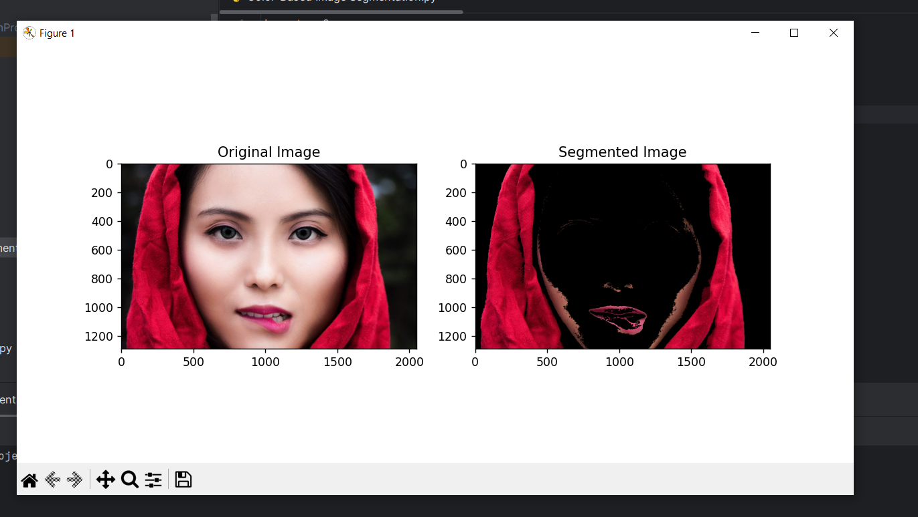

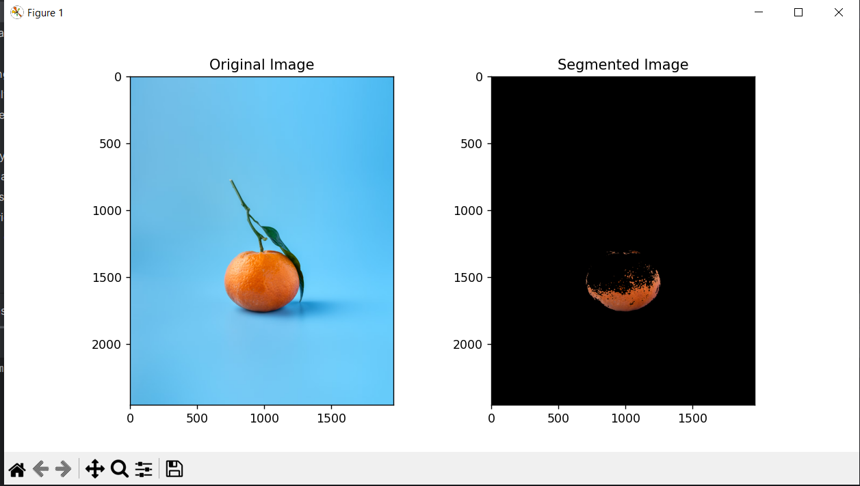

**2. Histogram Equalization for Color Images**

Objective: Enhance the contrast of a color image using histogram equalization.

Tasks:

Load and display an image.

Convert the image to the YUV color space.

Apply histogram equalization to the Y channel.

Convert the image back to the RGB color space.

Display the original and enhanced images side by side.

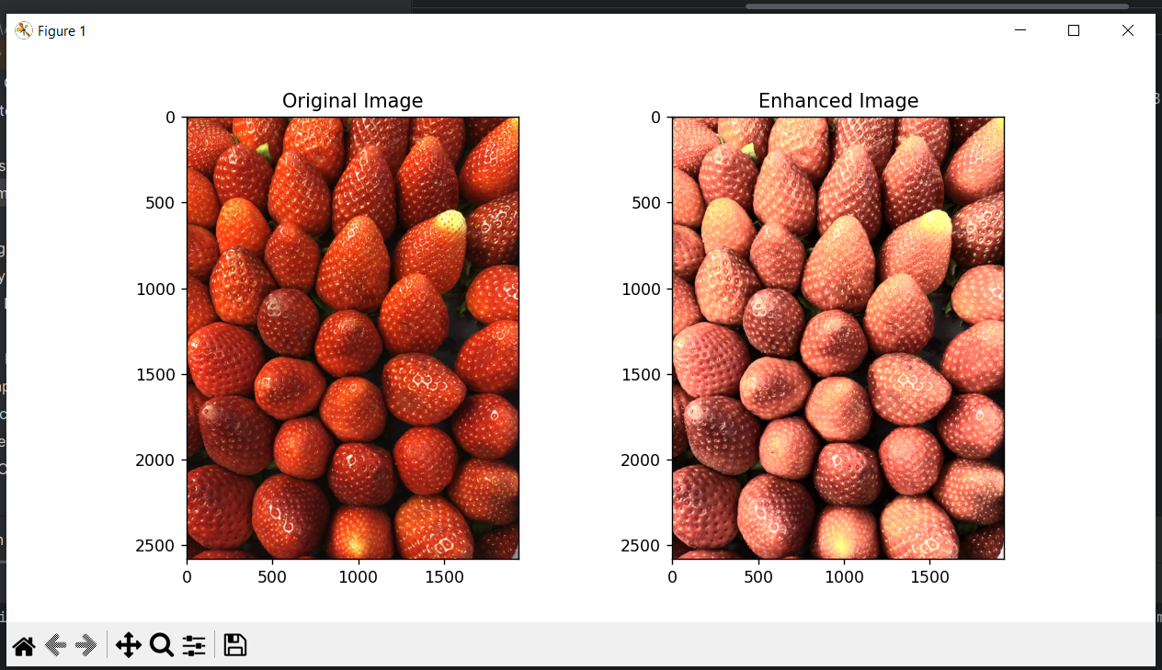

**3. Color Tracking in a Video**

Objective: Track a colored object (e.g., a red ball) in a video feed.

Tasks:

Capture video from a webcam or load a video file.

Convert each frame to the HSV color space.

Define the color range for the object to be tracked.

Create a mask and use it to find the object's contours.

Draw a bounding box around the object and display the video with tracking.

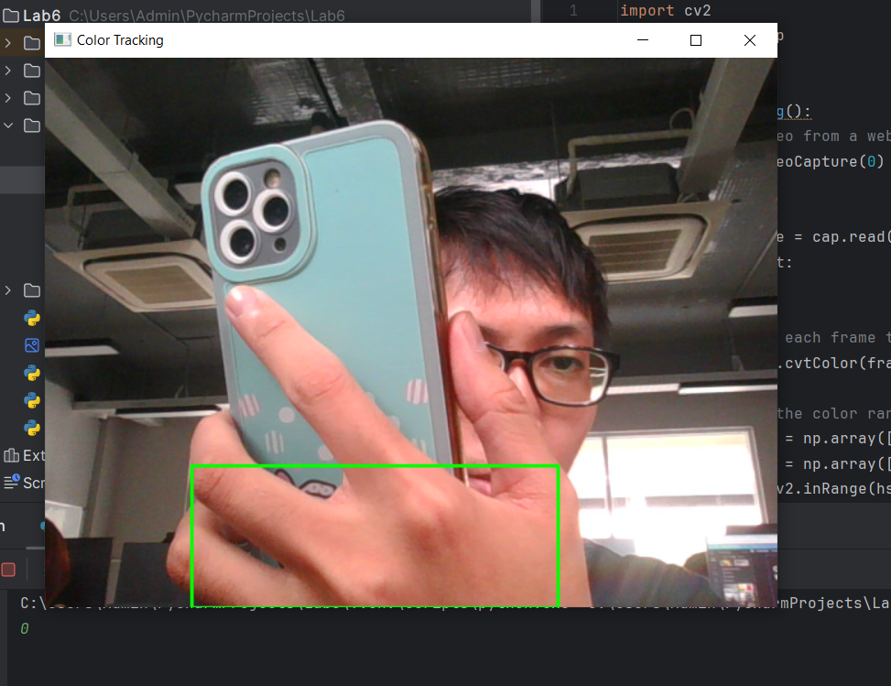

**4. Dominant Color Extraction**

Objective: Extract and display the dominant colors in an image.

Tasks:

Load and display an image.

Resize the image for faster processing.

Use K-means clustering to find the dominant colors.

Create a bar chart to display the dominant colors.

Display the original image and the color bar chart.

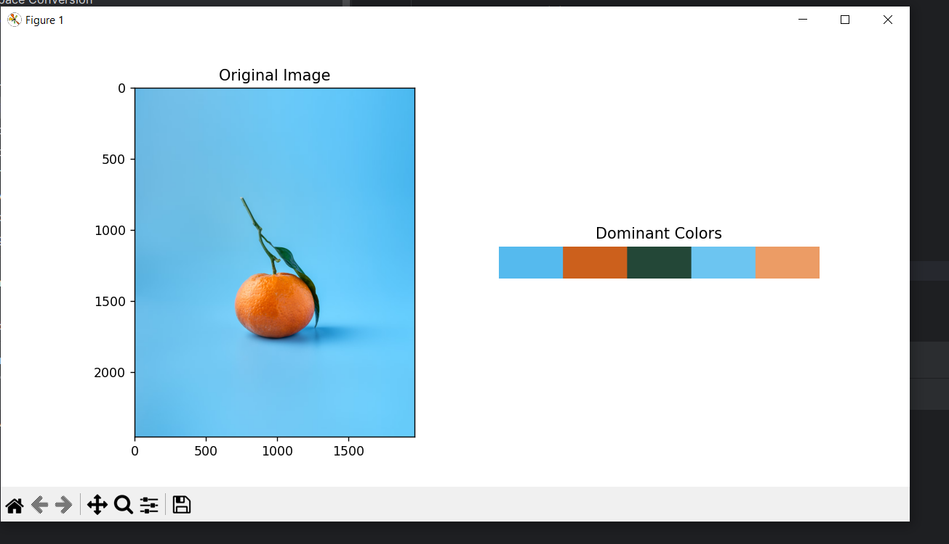

**5. Color Correction and White Balance Adjustment**

Objective: Correct the color balance of an image to make it look more natural.

Tasks:

Load and display an image with poor color balance.

Implement a simple white balance algorithm (e.g., Gray World Assumption).

Apply the algorithm to correct the image colors.

Compare the original and corrected images side by side.

